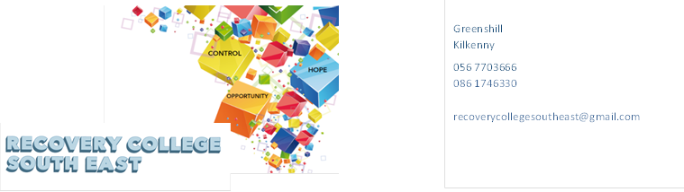
Greenshill
Kilkenny
R95 YYC0
Tel: 086 1746330
Email: recoverycollegesoutheast@gmail.com
Website: www.recoverycollegesoutheast.com

Recovery College South East – Wexford
Recovery Education Programme: April- June 2025

You are invited to join us on our new Recovery Education Programme.

For more detailed information on the workshops, please go to the Workshop Section of our Website – www.recoverycollegesoutheast.com.)

- Complete the attached enrolment form and email it to the Recovery College South East at enrolrecoverycollegesoutheast@gmail.com or
- Phone us on 086 1746330 to enrol

VENUE | WORKSHOP NAME | DATES | TIME
February - March 2024
Link,  Enniscorthy,  Y21 R2R1 | Personal Development  (8 week Workshop)  Personal Development 8-week workshop is designed to help individuals unlock their full potential, create a positive mindset, and develop the skills necessary to achieve personal and professional success.  Whether you're looking to enhance your self-confidence, improve your emotional intelligence, or build healthy habits that promote growth, this course will provide the tools and strategies to transform your life. | Every Wednesday  Starting From  30th April –  18th June | 10.30am –12.30pm
VENUE | WORKSHOP NAME | DATES | TIME
April - June 2024
Wexford Mental Health Association’  Henrietta St, Townparks, Wexford Town | Personal Development  (8-week Workshop)  Personal Development 8-week workshop is designed to help individuals unlock their full potential, create a positive mindset, and develop the skills necessary to achieve personal and professional success.  Whether you're looking to enhance your self-confidence, improve your emotional intelligence, or build healthy habits that promote growth, this course will provide the tools and strategies to transform your life. | Every Thursday  1stMay –  19th June | 2pm-3.30pm

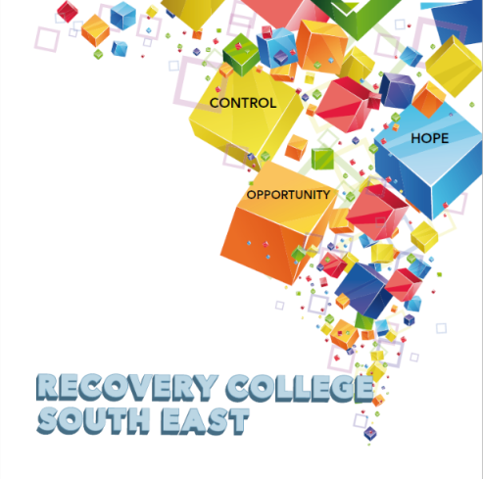


Greenshill
Kilkenny
R95 YYC0
086 1746330

recoverycollegesoutheast@gmail.com

Enrolment Form
Course title | Commencement date | In-house or Online (Zoom)  Please tick your preference below
 |  | In-house | Online (Zoom)
 |  | In-house | Online (Zoom)
 |  | In-house | Online (Zoom)

PLEASE COMPLETE USING BLOCK CAPITAL LETTERS
Surname:

First name(s)

Address:

Telephone: | Mobile | Home/Work
Email:
Contact Details in Case of Emergency: | Name | Number
Where did you hear about the Recovery College
Please tick the box that best describes you | Service User/Lived Experience_____________________________________  Family Member/Carer____________________________________________  Service Provider (Area of Work) __________________________________  _________________________________________________________________  Other (Please specify)/Prefer Not to Say____________________________________________  __________________________________________________________________
All our workshops are based around discussion and group work. Pen and paper would be helpful to have to hand for participants.
All our Workshops are free of charge.
Are you happy for us to contact you periodically by email, post or text about different events, workshops, surveys in relation to the Recovery College South East? (Please tick this box if yes.)

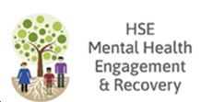

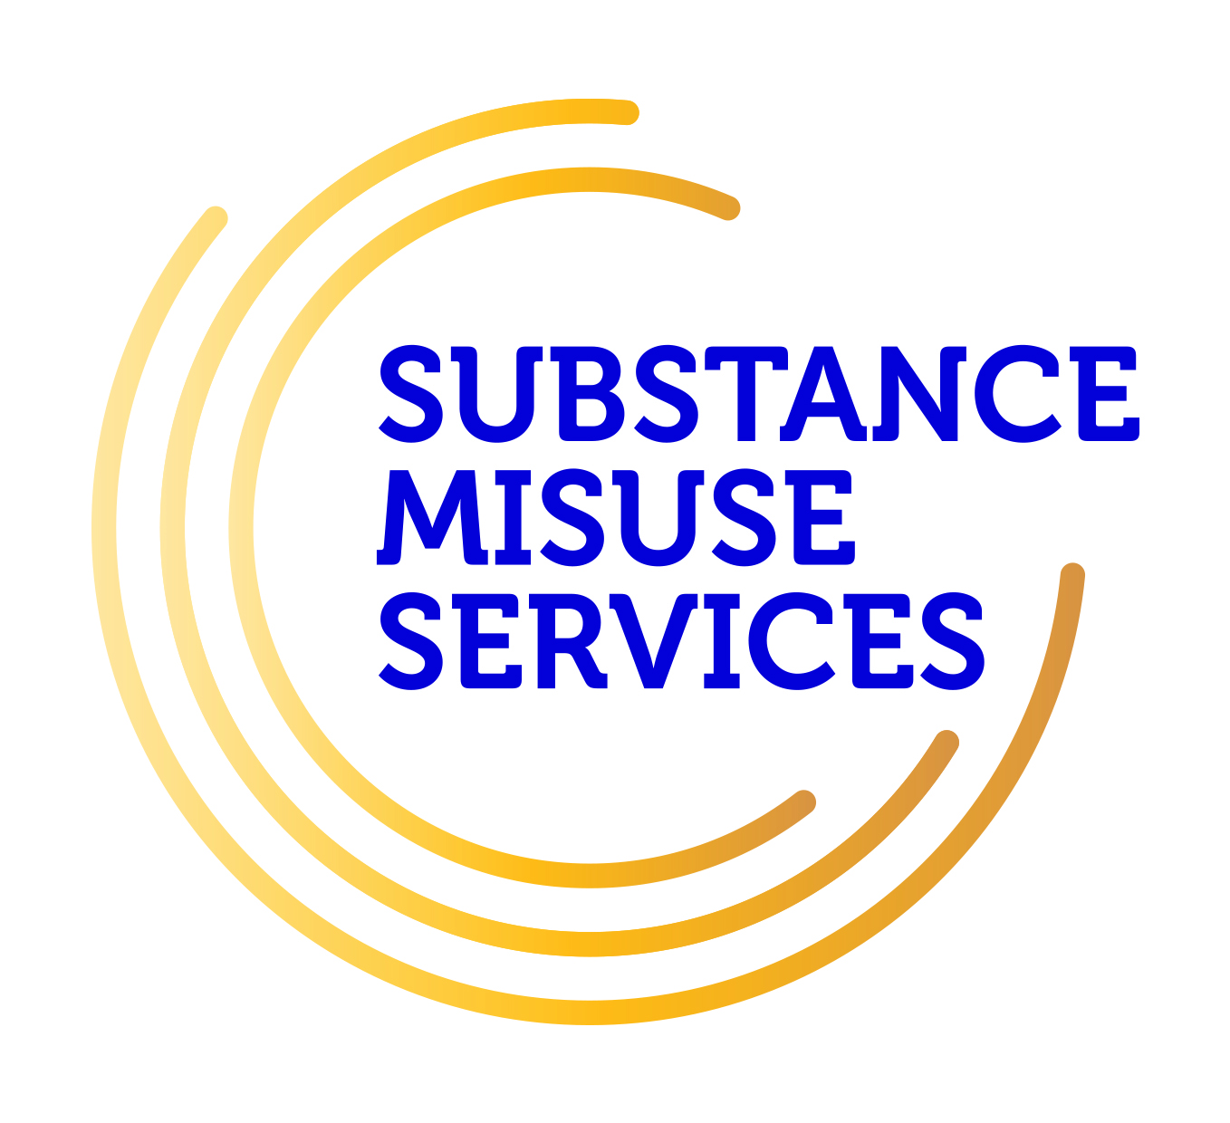
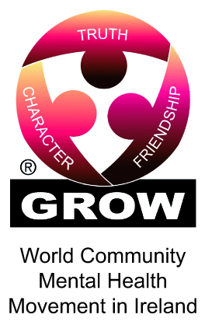




Student Signature _________________________________ Date _________________________
Recovery is moving on, achieving and learning, being the best and the best that I can be with confidence” Mental Health Discussion Group Clonmel 2013

