

In conjunction with

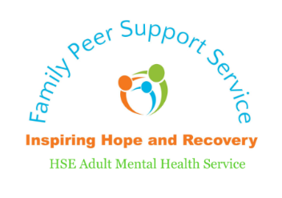

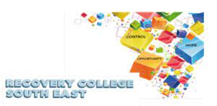



**In the Recovery College South East**

**9th of December 2022**

**10:00am – 1:00pm**

* Tea, Coffee and Scones
* Creating Wellness Tools
* Supportive conversation
* Mindfulness techniques
* Music and Mince Pies

**Wellness Conversation with Family Members and Supporters**