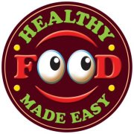
Healthy Food Made Easy
Tutor Training
______________________________________________

15th & 16th February
9.15am -4.30pm
Waterford (Venue tbc)

Health Promotion Division are seeking Tutors to deliver “Healthy Food Made Easy (HFME)” courses in the South East (CHO5).

HFME is a six week nutrition education and cooking programme which provides practical information on healthy eating and improves cooking skills by showing participants ways to provide healthy, nutritious, low cost meals and snacks.

The Tutor Training is 2 days in Waterford which aims to provide an overview of the HFME Programme and includes facilitations skills and practical information on the delivery of the programme. A HFME resource pack will be provided to all participants on completion of the training.

To apply complete application form attached and return to southeastHFME@hse.ie

Closing date for applications: Tuesday 6th February 2023

