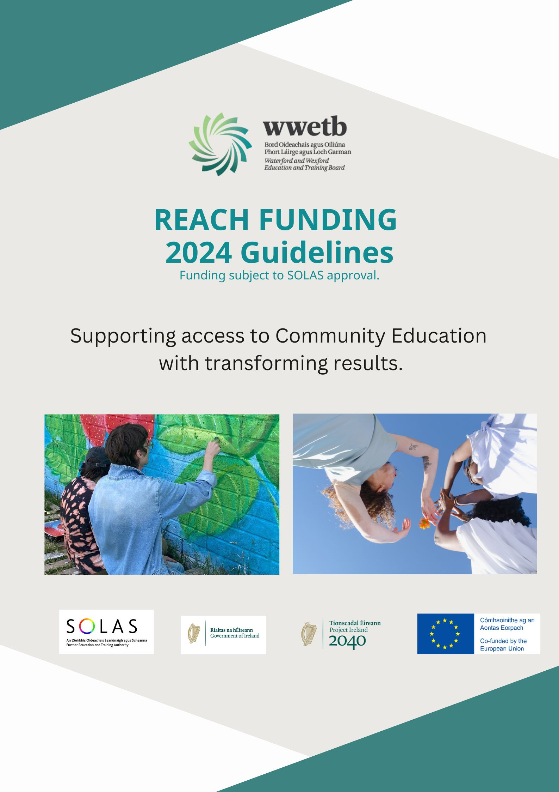

Closing Date:
friday 26th january 2024 @5pm
Table of contents

Introduction 3
Funding Categories 3
maedf / reach wwetb 2020/23 4
Conditions of funding 5
compliance with cl 13/2014 5
Grant thresholds 6
Report requirements 6
Application process 7
Examples of past reach projects 10
Ideas for reach projects 11
APPENDIX 1 PROCUREMENT GUIDELINES 12

Introduction
The aim of the Reach Fund (formally MAEDF) is to provide funding to support educationally disadvantaged learners. The fund places a strong focus on community education as a mechanism to continue to support and engage with disadvantaged learners.

Funding categories
ETBs to manage the application process and should consider for funding, proposals that
meet the funding categories as set out below:

1. Learner assistance fund, inclusive of education outreach/mentoring projects/transport costs for learners/urgent educational response.
2. Innovative green projects.
3. Projects focused on increasing participation in learning with target cohorts.
4. Events/awareness campaigns that contribute to equality policy and legislation.
5. In line with the ALL strategy, specific actions that;
• directly address those experiencing unmet literacy needs
• target funding on access to technology and devices
• expand community access to Wi-Fi and broadband resources
6. Community groups in pre-development phase to support the most marginalised and disadvantaged groups.
7. Support for refugee groups to support education and training delivery and promote/support cultural and social inclusion, including research and/or needs analysis.
Area | Total
Wexford | €869,604.05
Waterford City | €1,058,901.30
Co. Waterford | €370,774.06
Grand Total | €2,299,279.30
maedf / reach waterford wexford etb 2020-2023

Conditions of funding
Expenditure
Approved funding allocation for any project under the Reach fund must:
- be used for the specific purpose intended.
- be expended by 2024 year-end.
- not be used for any pay costs or costs of a recurring nature.
- Any REACH funding used for staff costs must ensure that staffing commitments /contracts are for specific purpose or fixed term and that the commitments / contracts cannot extend beyond the end of 2024.

Allocation of funding
Each ETB, in determining the allocation of funding under Reach, should ensure the following factors are satisfied:
1. The application for funding will be reviewed by an approvals team.
2. All governance requirements and assurances on how this funding would be spent, if approved, have been satisfied.
3. There is no duplication of State funding.
4. Conditions of funding are complied with.

For compliance with CL 13/2014 all applications must:​
- Be accompanied by Current Tax Clearance Certificate​
- Have End of Year Accounts detailing any previous funding from WWETB​.
- Inform WWETB if exchequer funding exceeds 50% of income​, if involved in a multiple co-funding arrangement
- Submit the required number of quotes with the application, if application includes capital expenditure.

Grant Threshold
Groups can not apply for more than €50,000.

Reporting requirements
- Monthly reports on all work done, including financial returns with receipts/invoices. Guidelines and templates for these reports will be provided by WWETB.
- These templates must be followed.
- Applicants must maintain all appropriate records.
- Spot check financial monitoring will be applied to all grantees.
- Reach funding will be subject to C & AG audits and Internal Audit Unit

Application Process 2024
Please read the guidelines before submitting your application.
Waterford Wexford ETB invite Community Education providers to make an application under the criteria set out in these guidelines.
Applications to the fund must be returned to your local CEF no later than 5pm on Friday 26th January 2024
Waterford County- ainewhelan@wwetb.ie
Waterford City- deborahbutler@wwetb.ie
South Wexford- bridinlyngmoloney@wwetb.ie
North Wexford- yvonneoconnor@wwetb.ie
All applicants are required to:
- Link with local CEF regarding proposal and guidance on same before submitting an application form
- Attend information session regarding the Reach Grant Scheme
As part of the application process, applicants may have a site visit by WWETB Community Education Team.
Applications will be reviewed by an internal ETB Review Panel before being recommended for approval.
Late applications will not be considered.

Please note the following:
- Funding must be expended in full by the end of 2024 and there will be no carry over of funding into 2025.
- Governance and procurement procedures and responsibilities will apply.
- Funding is subject to SOLAS approval in 2024
- There will be a cap of €50,000 on individual applications with payment in instalments
- Applications may be subject to a Financial Robustness test (bankruptcy status/companies registration/financial status) If the application does not pass the test the application will not proceed
- Applications must be accompanied by relevant quotes.
- A detailed education and training plan must be submitted with the application where relevant.
- Applications will be subject to a double funding check by WWETB with other State Agencies
- Applications must ensure there is a focus on mitigating educational disadvantage and must ensure an impact at community level.
- Ideally proposals/applications will target learners at levels 1-3 but may target learners at level 4, 5 and 6 where the fund is used to target learners who are likely to experience educational disadvantage that impacts their participation in learning,
- Monthly reports on all work done, including financial returns with receipts/invoices. Guidelines and templates for these reports will be provided by WWETB. These must be followed.
- Applicants must maintain all appropriate records.
- Grants directly to learners are not being considered under this fund.
- The fund cannot be used for pay costs or for recurring costs (e.g. core employee costs)
- Partnership companies (LCDC and Local Development Companies) can only apply to the fund where they are applying for funding on behalf of a specific community partner and must report on the funding and its use for the community organisation that benefitted,
- Currently the fund is not open to Specialist Training Providers e.g., NLN where they have access to similar funding. Applications will be considered only in cases where the provider can demonstrate the application does not overlap with funding from a core funder or similar.
- Data provided will be stored and managed in line with WWETB Data Protection Policy and in line with GDPR.
- A scoring matrix will be applied to all applications.
- All paperwork from previous Reach/MAEDF must be submitted before Reach 2024 application will be considered.

If you have queries on the application process or the terms and conditions of the fund, please feel free to contact any of the above named CEFs.

past examples of reach/maed funded programmes
Ballyroebuck Hall- This project worked with a rural community, in line with the National Broadband plan, to improve digital connectivity and to develop classes to improve digital skills. The project built on the community hall’s digital infrastructure and enabled them to provide devices and software for new learners. A number of 1-2-1 ‘Bring your own Devices’ programmes were ran by the project.

Raheen FRC- This programme used the funds for a variety of different projects. With a focus on sustainability, a large amount of ‘Food Waste’ equipment was purchased, along with sewing machines and upholstery equipment. This enabled the centre to run classes for the local, rural community, along with a large cohort of Ukrainian refugees, in stopping food waste, and in mending and making your own clothes. Classes were also run in horticulture, crafting and facilitation.

Dunhill Community Garden encourages the integration of local people and the Ukrainians living in Tramore and Waterford. The most positive aspect of this project is that diverse groups of people come together, forget their cares for a while, learn together, laugh together, craft and eat together despite language barriers.

Klub Muzik provides music education programmes for adults that would not traditionally have access to music programmes. Target groups include adults with intellectual disabilities and vulnerable adults. Each group meets weekly and has an opportunity to perform which boosts confidence, promotes a sense of accomplishment while improving health and wellbeing.

Some possible REACH funded projects
Project One Start a basic upcycling service where individuals are supported to upcycle small pieces of furniture which in turn may provide employment opportunities for them while attaining new skills. The grant funding allows for a tutor to introduce and demonstrate new skills and methods related to upcycling and for the purchase of materials for use on each furniture piece.

Project Two An outreach programme which would specifically focus on matching individuals with appropriate mentors to support them in the development of key skills and attributes related to both returning to education and moving forward ion their careers. For those who are still affected by the restrictions experienced during the pandemic, the process of reintegration to education through the provision of such a programme which is suitable to the needs of individuals is vital.

Project Three To establish a learner assistance fund to support learners to have access to, a choice of, and an opportunity to participate in a full range of education, training and community integration options. The fund would help by removing financial barriers to individuals and would cover supports such as childcare costs, travel costs, fees and other costs.

Project Four Offering mentoring and support programme to those who are high risk of homelessness. This would be achieved by raising awareness of what opportunities are available to them and promoting re-engagement with the community as a whole.

Project Five To introduce the communities to gardening and horticultural skills towards growing their own food. Learners would also be introduced to Water sustainability, Bio Diversity and environmentally respectful growing and gardening practices.

