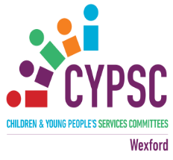
Review of the experience of community/voluntary sector workers who are supporting young people with mental health difficulties in County Wexford

Participant Information
Wexford CYPSC has a “Young People and Mental Health” Sub Group. This group has identified that the community/voluntary sector experience particular issues in relation to supporting young people who may be experiencing mental health difficulties.

There are no barriers to providing universal support and responding to issues that are considered to be “mild to moderate”. Challenges arise when young people present with complex needs and referrals to a more appropriate service are either unsuccessful or young people are placed on long waiting lists. This frequently leaves front line workers in a position where they feel that they do not have the experience, knowledge or clinical insight to adequately support a young person.

The Young People & Mental Health Sub Group has developed an online survey which will be distributed to those working in the community and voluntary sector. The survey can be filled anonymously. The survey findings will document the experiences of professionals working with young people and their families in County Wexford and identify recommendations for improved service delivery.

You are asked to share this survey link with your staff members. Alternatively, you can share the QR code on the following page. The survey is estimated to take 8-10 minutes to complete. Closing Date for receipt of surveys is Friday 3rd May

The recommendations from this research will be shared with Wexford CYPSC and will be made available to relevant service providers to assist with the planning, design and delivery of their services to children, young people and families. We are currently in the process of developing the next Wexford Children & Young People’s Plan 2024-2026. The findings from the survey will be used to inform the next plan.

Thank you in advance for your assistance in sharing the survey with your staff members.

Kind Regards,

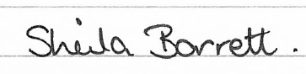
On behalf of the CYPSC YPMH Sub Group

