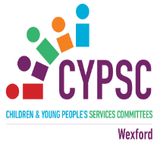

National Breastfeeding Week Campaign October 1st-7th

“Feeding the Future : Supporting Breastfeeding through a Pandemic and Beyond”

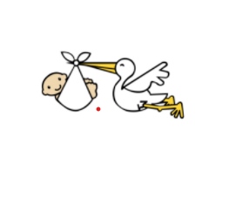

National Breastfeeding Week takes place from October 1st -7th 2021. The theme of the HSE Mychild.ie campaign this year is “Feeding the future: Supporting breastfeeding through a pandemic and beyond”

Through its “Health & Diversity” Sub-Group, Wexford Children & Young People’s Services Committee (CYPSC) is running a campaign to support National Breastfeeding Week. This includes highlighting national and local supports for those who are currently breastfeeding or who are considering doing it in the future.

What’s Happening Nationally…….

Breastfeeding Resources : Friday 1st October 11-12pm: Launch of new breastfeeding resources by Pavee Point: A series of short videos, a breastfeeding Q&A booklet and briefing paper.

Breastfeeding Support Groups : Whilst continuing with virtual meetings, breastfeeding support groups have been given the green light to resume face to face meetings from September 20th 2021 in line with the recent government announcements on the easing of restrictions. The breastfeeding support groups section on mychild.ie will be updated to reflect face-to-face supports available as they come on stream over the coming weeks and months.

Lactation Consultant: Did you know that if you have any questions or concerns, you can talk to an expert Lactation Consultant on the free “Ask our Expert” service. Your question will be reviewed and responded to within 24 hours. You can also and live web chat provided by Lactation Consultants between 10:00am and 3:00pm on weekdays. For more information see here

Lactation Consultants have experience in supporting parents and have answers to all sorts of breastfeeding questions. You can also search the mychild.ie website for the relevant topic, where you will find articles that match lots of common questions that parents have. See here for more information.

What’s Happening in Co.Wexford….

- “Parenting Today” : As part of the “Parenting Today” series of online talks hosted by Wexford Public Library Services and Wexford CYPSC, a video to promote and support breastfeeding has been developed. This video features inputs from the HSE Child Health Programme Development Officer, a Lactation Consultant and a Breastfeeding Counsellor from Cuidiú. The video will be available to access on Thursday 7th October at 7.00pm on the Wexford County Council YouTube channel at https://www.youtube.com/c/WexfordPublicLibraries. For a full list of online” Parenting Today” talks click here.

- Southend Family Resource Centre : Plan to have a Breastfeeding Hub on Thursday morning October 7th from 9.30am to 12pm

- Traveller Community : The Traveller Community Health Workers have been discussing breastfeeding with new pregnant mothers as the opportunity arises. They have been using “Traveller Mothers and Babies – Supporting Traveller Women During and After Pregnancy” booklet from Pavee Point as a guide.

- FDYS : The Roma Health Advocates will be having a get together with the Roma Women’s Group to talk about the women’s experience with breastfeeding. They will discuss the challenges experienced and will help younger mothers with advice.

Sources of Information and Support……

Mychild.ie : Mychild.ie is a guide to pregnancy, baby and toddler health. It contains a wealth of knowledge for new parents from trusted experts. There is lots of information and support available for those who are breastfeeding or are thinking about it. Click here to access the site.

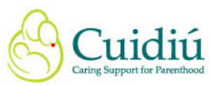
Cuidiú aims to provide support and education for parents and guardians to empower them to make informed choices. Cuidiú’s motto is “Education and support for parenthood”. You can access Trained Volunteer Counsellors and Support Groups. For information on the Wexford branch of Cuidiú see : https://www.cuidiu.ie/wexford.
You can also find information on Facebook https://www.facebook.com/cuidiuwexford and Instagram
https://www.instagram.com/cuidiuwexford/
Cuidiú Wexford is having a virtual breastfeeding group to celebrate National Breastfeeding Week 2021 on Wednesday October 6th from 11:00-12:00. Details on how to register and join will be available on Cuidiú Wexford Social Media
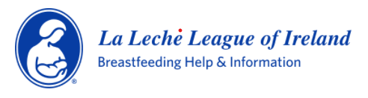
La Leche League is a voluntary organisation whose mission is to help mothers worldwide to breastfeed through mother-to-mother support, encouragement, information, and education, and to promote a better understanding of breastfeeding as an important element in the healthy development of the baby and mother.
For contact details or information on our online meet ups any other events see Facebook
www.facebook.com/LaLecheLeagueArklowandEnniscorthy
La Leche League Arklow/ Enniscorthy is hosting an outdoor meet up on Thursday 7th October at 10 am for National Breastfeeding Week in Cosy Cottage Cafe, Gorey. Pre Booking is essential as spaces are limited. Please PM the Facebook page to book.

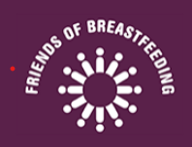 Friends of Breastfeeding Ireland

Friends of Breastfeeding works to ensure that women in Ireland achieve their desired breastfeeding experience. We network to connect women in Ireland who want to breastfeed with their local support system. We work to build communities of supportive friends, family and health professionals – “friends” of breastfeeding.All Mum2Mum Support Groups will probably be restarted in the New Year, but our virtual meets are still on Facebook every Wednesday. https://www.facebook.com/FoBfIreland

