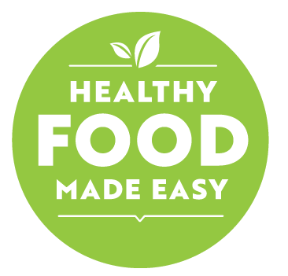
Healthy Food Made Easy (HFME) is a community cooking programme developed under the Sláintecare Healthy Communities Programme. There will be about 8-12 participants in each class and it is run within the community. Participants take active part in the programme, which focuses on improving:
- cooking skills
- eating behaviours
- nutrition knowledge

Background to Healthy Food Made Easy
The programme was developed by HSE community dietitians. Their trained tutors and peer leaders deliver the programme. Your peer leader is a person from your own community who has been trained to guide you through HFME. The aim is to help you to make healthier food choices within your budget. Across the country, many partnerships have been put together between the HSE and community development organisations to run the programme in local communities.

Who is this programme for?
The programme is suitable for everyone. It is particularly helpful to:
- parents’ groups
- youth groups
- members of the Traveller community
- families living in homeless hubs
- families attending family support services
- groups of people over 65.

What can participants expect if I take part in the programme?
- the different nutrients in food and how they can improve your health
- how to use the food pyramid to plan meals
- how to read and understand food labels
- how to plan shopping and meals within your budget
- how to cook simple yet tasty meals

Course Outline

Session 1: Building the food pyramid
- decide as a group the foods you will cook over the next few weeks
- be introduced to the programme and other participants
- learn about the food pyramid

Session 2 :The fibre providers
- learn about fibre and how it works in the body
- identify fibre-rich foods, food labelling and its importance for good health

Session 3: Focus on fats
- learn about the relationship between food, energy and physical activity
- learn about the different types of fat
- talk about the ways of reducing the amount of fat you eat

Session 4: Food for life
- learn about the different nutritional needs of people through the different life stages
- identify issues which make it difficult to put healthy eating into practice

Session 5: Shop smart!
- discuss how you shop and what you buy
- learn how to plan your shopping
- explore food labelling

Session 6: The road ahead
- plan how to use new skills to make long-lasting changes to eating habits
- think about what you have learnt during the programme
Sessions 2–6 include opportunities to use what you have learned in the programme in a practical way.

How are courses run and managed?
The course is run over two 2 ½-hour sessions each week. It will be held in your own community. You will have the opportunity to take part in practical cookery sessions.
Depending on your area, a community organisation or charity will run the programme. You will find contact details for your area at the end of this page.
During the programme, a Dietitian registered by the Dietitians Registration Board (CORU) will visit the group to answer any questions you have about nutrition.

What positive changes will participants see from taking part in the programme?
Participants that take part in the programme, will:
- eat more fruit and vegetables: up to 1.5 portions per day
- feel more confident in your cooking skills
- know more about nutrition
- be more likely to cook at home than get takeaways
- eat a bigger variety of food

How can organisations get involved?
Speak with your local Health Promotion Officer and/or contact Leighann at southeastHFME@HSE.IE

