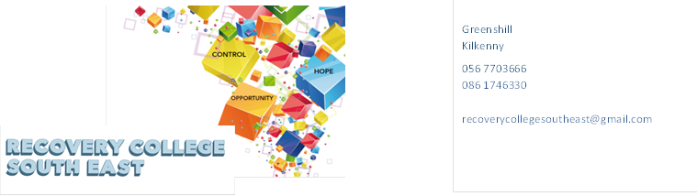
Website: www.recoverycollegesoutheast.com
Recovery College South East – Link Training Centre Enniscorthy
Recovery Education Programme: January – March 2024

You are invited to join us on our new Recovery Education Programme for the New year.

(For more detailed information on the workshops, please go to the Workshop Section of our Website – www.recoverycollegesoutheast.com.)

- Complete the attached enrolment form and email it to the Recovery College South East at enrolrecoverycollegesoutheast@gmail.com or
- Phone us on 086 1746330 to enrol

VENUE | WORKSHOP NAME | DATES | TIME
January – March 2024
“Link”  Enniscorthy  VENUE WORKSHOP NAME DATES TIME  April – June 2023  “LINK”  Enniscorthy | Series of ten week recovery education programme  Understanding and Managing Anxiety  (4 week workshop)  Everyone experiences periods of anxiety at some stage in their lives. Anxiety is a word used to describe these moments of discomfort. Anxiety can change from something everyone experiences in mild forms, to something which, is persistent, excessive or over-whelming. It can begin to interfere with many aspects of our life – from confidence, to physical wellbeing and engagement in basic or complex activities of living.  The aim of this four-part workshop is:  - To explore the facts around anxiety  - To explore the causes and symptoms of anxiety  - To look at how anxiety affects people in different ways  - To explore practical and effective ways of managing and living with anxiety. | Every Thursday  18th January  25th January  1st February  8th February | 9.30am-11am
 | Sleep  Discussing the importance of sleep and what we can do to get a good’s night’s sleep | Thursday 15th February | 9.30am-11am
 | WORKSHOP NAME  January – March 2024  Understanding and living with Psychosis /Paranoia  While psychosis/paranoia is surprisingly common, it can be a very unsettling and frightening experience for the person experiencing it as well as the people who care about them. This workshop is for anyone who wants to better understand psychosis and paranoia and learn effective ways of living well with it.  The aim of this workshop is:  - To help you to understand psychosis and paranoia through exploring existing knowledge and different perspectives around the topic  - To provide coping strategies for living with psychosis/paranoia and for promoting recovery | DATES  April – June 2023  Thursday  22nd February | TIME WORKSHOP NAME DATES TIME  April – June 2023  9.30am-11am
 | Loneliness, Isolation and Reconnecting (3 week workshop)  This workshop explores how loneliness and isolation impacts on all aspects of life and shares ideas on how loneliness and isolation can be positively addressed.  The aims of this workshop are:  - To explore how loneliness and isolation impacts on all aspects of life  - To share ideas on how loneliness and isolation can be positively addressed  - To identify practical ways of reconnecting with society and making new connections.  - To explore what’s available in your local community both online and in person. | Thursday  29th February  7th March  14th March | 9.30 – 11am

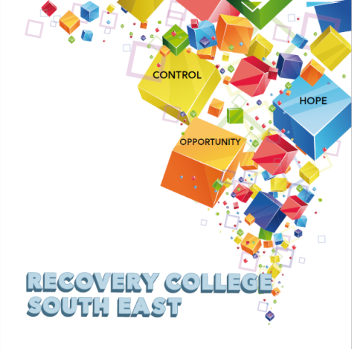

Greenshill
Kilkenny
056 7703666
086 1746330

recoverycollegesoutheast@gmail.com

Recovery College South East Enrolment Form
Course title | Commencement date

PLEASE COMPLETE USING BLOCK CAPITAL LETTERS
Surname:

First name(s)

Address:

Telephone: | Mobile | Home/Work
Contact Details in Case of Emergency: | Name | Number
Email:

All our workshops are based around discussion with some written exercises at your own discretion.

All our Workshops are free and our workshops are open to everyone.

Are you happy for us to keep you informed by email, post or text about the Recovery College South East or future courses? (Please tick this box if yes. )

Student Signature _________________________________ Date _________________________
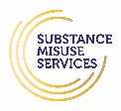
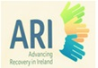
Recovery is moving on, achieving and learning, being the best and the best that I can be with confidence” Mental Health Discussion Group Clonmel 2013

