Wexford Restorative Practice Partnership
Wexford Restorative Practices Partnership (WRPP) is a new multi-agency body established recently with the objective of developing restorative practices in County Wexford. The new entity was officially launched at a conference in Enniscorthy on 12th October where sixty professionals from the areas of education, children and youth services, criminal justice and community development, gathered to hear a panel of experts speaking on the benefits of incorporating restorative practices into their services and work.
WRPP grew out of an action put forward by the Young People & Mental Health Working Group and included in the plan for the county by County Wexford Children and Young People's Services Committee. This action is being led by Wexford Local Development through the Cornmarket Project and calls for the development of restorative practices on a county-wide basis.

Restorative practice is a way of working with people that is based on the philosophy that when people are given ownership and responsibility for their actions, there is a greater likelihood of positive, long-term interaction with other people, the development of empathy with others, and the establishment of healthy and productive communities. Speaking at the launch of WRPP, the chairman Paul Delaney stated that ‘we are very fortunate in that we already have accredited restorative practice facilitators and trainers who are now part of WRPP and it is our intention to offer training in Wexford next year to those who can benefit from incorporating this approach into their work’.
Interest in using restorative practice in County Wexford continues to grow and WRPP was delighted to see Wexford County Council support this approach. This is reflected in a motion, put forward by Councillor Barbara-Anne Murphy, to the meeting of Wexford County Council held on Monday 14th November. The motion which was unanimously passed read ‘I call on Wexford County Council to examine the potential of Restorative Practice as an approach to internal and external conflict resolution for members, staff and the public’.
Membership of WRPP currently includes: TUSLA Child and Family Agency, County Wexford Children and Young People’s Services Committee, HSE Suicide Prevention Office, the Probation Service, Waterford Wexford Education and Training Board, Wexford Education Centre, Wexford Local Development, the Garda, Slaney Youth Diversion Project, Ferns Diocesan Youth Service, Youth New Ross, SAFE Youth Diversion Project and the Cornmarket Project.
It is intended to roll out training in restorative practice throughout County Wexford in 2017 and all those interested in developing their skills in this area can register their interest by emailing Aislinn at wexfordrpp@gmail.com.

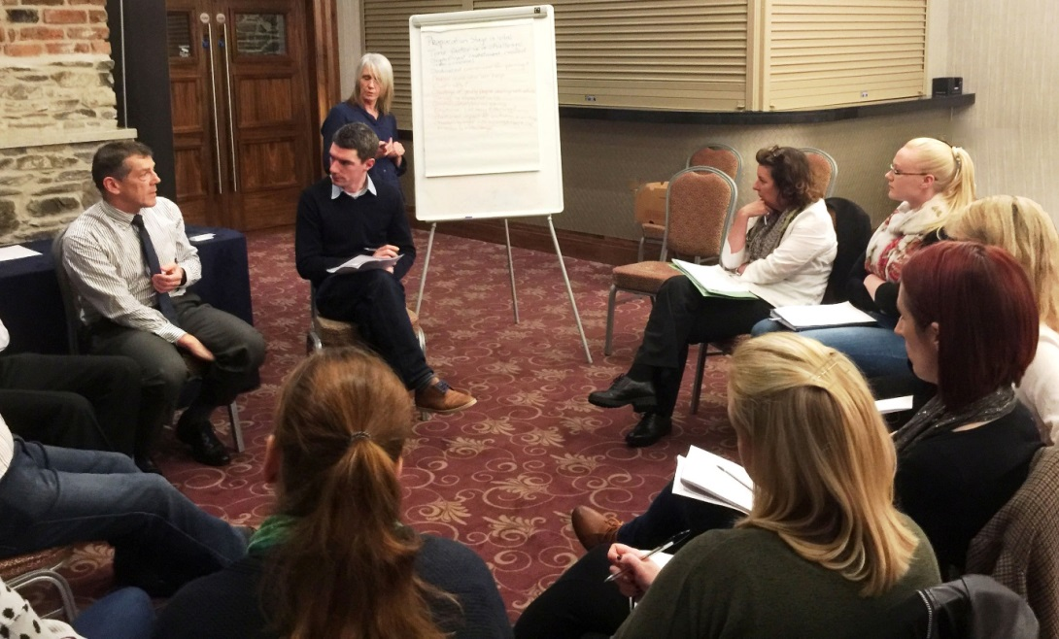

Participants at the Wexford Restorative Practices Partnership Conference. L-R, Garda Inspector Andy Tuite, National Garda Crime Diversion Office, Tommy Somers, Restorative Practices facilitator, Tina Suter, Cornmarket Project, Michele Weir, Senior Probation Officer and Iseult Nichoitir, Waterford Restorative Practices Network.

