Mar
+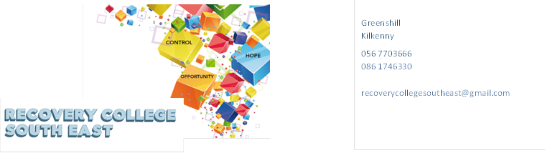
Website: www.recoverycollegesoutheast.com
Recovery College South East – Online Recovery Education Programme for Families and Supporters
You are invited to join us in our new Online Recovery Education Programme. It is free and will help us all feel connected and supported during these times of uncertainty.
Follow the simple steps below to connect to our online interactive workshops.
(For more detailed information on the workshops, please go to the Workshop Section of our Website – www.recoverycollegesoutheast.com )
- Complete the attached enrolment form and email it to the Recovery College South East at enrolrecoverycollegesoutheast@gmail.com or forward it to us by post.
Alternatively
- Phone us on 086 1746330 to enrol
- Download the free ZOOM app on your mobile phone or/and your laptop.
January 2022
Understanding Diagnosis for Families and Supporters |  | Wednesday 19th January | 10am – 12pm
How Mental Health Challenges can affect Families and Supporters |  | Wednesday 26th January | 10am – 12pm
February 2022
Healthy Communication Skills for Families and Supporters |  | Wednesday 2nd February | 10am – 12pm
Information and Advocacy for Families in Recovery (Evening Workshop) |  | Wednesday 9th February | 7pm – 9pm
Understanding and Managing Co-Dependency within Family Recovery |  | Wednesday 16th February | 10am – 12pm
Steps towards Healing and Forgiveness in Family Recovery |  | Wednesday 23rd February | 10am – 12pm
March 2022
Mental Health and Family Caring and Supporting the Supporters Programme (5 week programme) |  | Wednesday 2nd, 9th, 16th, 23rd and 30th March | 10am – 12pm
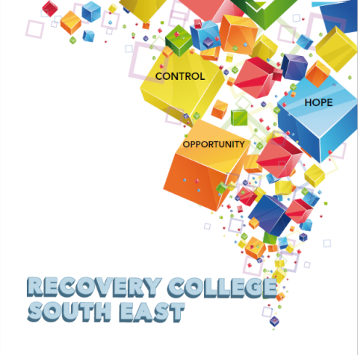

Greenshill
Kilkenny
056 7703666
086 1746330

recoverycollegesoutheast@gmail.com

Recovery College South East Enrolment Form
Course title | Commencement date

PLEASE COMPLETE USING BLOCK CAPITAL LETTERS
Surname:

First name(s)

Address:

Telephone: | Mobile | Home/Work
Contact Details in Case of Emergency: | Name | Number
Email:

All our workshops are based around discussion and group work. Pen and paper would be helpful to have to hand for participants.
Please note that we ask for your address and also an emergency contact number of a person who will come to your aid in times of an emergency during a virtual ZOOM workshop. For example, if a student collapses during a ZOOM workshop and is on their own in the house, we will be unable to support you without your address and contact number of a person who can call to your house. This has never happened but it is important that we are prepared if it does, and the facilitators can support you.

All our Workshops are free of charge.
Your contact details will be forwarded to the Recovery College South East. Are you happy for us to keep you informed by email, post or text about the Recovery College South East or future courses? (Please tick this box if yes.)

Student Signature _________________________________ Date _________________________
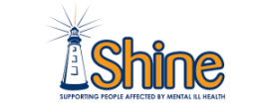
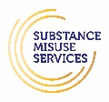
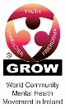
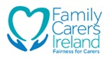
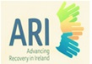
Recovery is moving on, achieving and learning, being the best and the best that I can be with confidence” Mental Health Discussion Group Clonmel 2013

Greenshill
Kilkenny
056 7703666
086 1746330

recoverycollegesoutheast@gmail.com

Workshop Descriptors
Workshop Title | Description
Healthy Communication Skills for Families and Supporters | Family relationships can have ups and downs or go through times of difficulty.  Family boundaries define who is responsible for what, how parents and children interact, and how the family relates to the outside world. Communication within the family is extremely important because it enables members to express their needs, wants and concerns to each other.  The aim of this workshop is:  - To explore how to communicate effectively within your family  - To look at how you might set some healthy family boundaries for everyone
How Mental Health Challenges can affect families and Supporters | Looking after a family member with a mental health challenges can be an extremely stressful time and coping with the stress may cause family life to become unsettled and unpredictable  The aim of this workshop  - To explore the affects Mental Health challenges has on all family members, supporters and friends.  - Explore tips and tools on how to manage these challenges
Information and Advocacy for Families in Recovery | Family recovery is about all members of the family being able to live a life of their own choosing regardless of the challenges of mental health issues. Navigating Mental Health Services can be very challenging for families, as well as knowing where to go to for support and information.  The aim of this workshop is:  - To explore how Mental Health Services works  - Explore how families and supporters can be an added resource to the service and to the person they are supporting.  - Signpost to community family supports
Mental Health & Family Caring Program  (5 Week Workshop) | This workshop will support you in building skills to look after your own wellbeing whilst caring for a person living with a mental health challenge.  The Aim of this workshop is :  - To reflect on and build tools and techniques to enhance self-care  - Expanded your understanding of the concepts of mental health, mental illness and recovery  - Increased awareness around boundaries with regard to personal wellbeing and the caring role  - To learn more about communication skills and active listening techniques  - Learn about what supports and services are available for families
Step towards healing and forgiveness in Family Recovery | During recovery, the importance of forgiveness and healing is crucial. Acknowledging pain, learning from mistakes and releasing anger and resentment are key components of forgiveness in recovery.  The aim of this workshop is:  - Explore different Strategies on how supporters can heal and move forward in their recovery.
Understanding and Managing Co-Dependency within Family Recovery | Co-dependency is a concept that initially emerged in the addictions field in the 1970s to address complex family relations that occurred as a result of substance dependencies (Calderwood, 2018). Co-dependency generally describes a one-sided relationship whereby one person almost entirely relies on the other for meeting their emotional and psychological needs.  The aim of this workshop is:  - Explore the concept of co-dependency and how it can develop within families  - Discuss the challenges it can cause for families as well as effective ways of managing Co-dependency.  - Explore effective ways of managing Co-dependency.
Understanding Diagnosis for Families and Supporters | This interactive workshop aims at helping families to understand the value and relevance of a diagnosis  The aim of this workshop is:  - To introduce the relevance of diagnosis to participants, so that they can develop a broader understanding of the process of how a diagnosis is made  - To look at the supports available for families.

