You are invited to apply for a place on ...

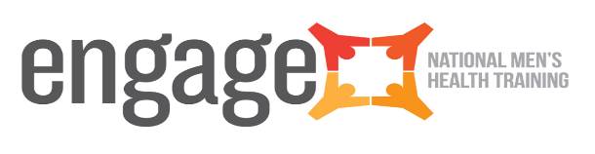
Connecting with Men

Date: Wednesday 10th April 2024

Time: 9.15am – 4.30pm

Venue: Kilcannon Garden Centre, Old Dublin Road, Kilcannon, Enniscorthy, Co. Wexford

A one day training course for health professionals and community workers who work with men

Aim of the Workshop
The aim of this workshop is to assist a broad range of practitioners and service providers to explore the world of males, and to develop practical strategies for effectively engaging with them around health and wellbeing issues. It focuses on the engagement process (i.e. WHY and HOW to build relationships with men) rather than offering a new or revised health programme (i.e. WHAT to offer them).

Objectives of Workshop
The key objectives for this workshop are to:
- Reflect upon how to create a ‘safe space’ for working with men.
- Gain a common understanding of what men’s health is and why it is important.
- Explore how gender influences the values and attitudes that men develop in relation to their health, and how this influences their health behaviours.
- Identify some of the determinants that shape health outcomes for men.
- Reflect on participants’ own value base, experience, skills, attitudes towards and expectations of men.
- Explore what a ‘male friendly’ health programme or service looks like in practice.
- Signpost participants to further sources of help, advice, guidance and support.

Who Should Attend?
This workshop will be of interest to a broad range of service providers and practitioners who wish to connect in more meaningful ways with men.

Cost
The ‘Connecting with Men’ workshop is free for all participants.

To Apply
To apply for a place on this workshop, please follow the link below:

- https://bookwhen.com/southeasttraining/e/ev-sp2c-20240410091500

Further Information
For further information contact Ann Bates (ann.bates@hse.ie) / Colm O’Connor (colm.oconnor@hse.ie)
